**Java Singly Linked List**

**Main Menu:**

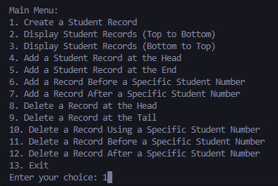

**Create**:

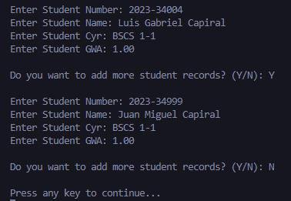

**Student Records (Top to Bottom)**

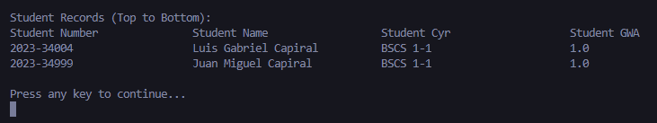

**Student Records (Bottom to Top)**

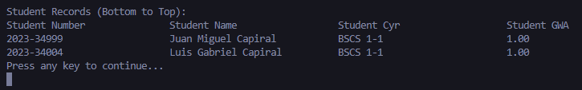

**Add at Head**

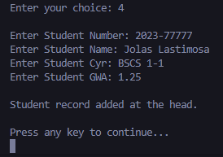

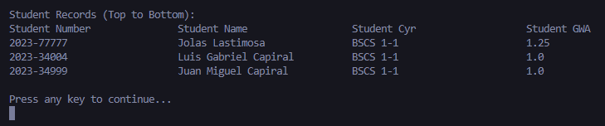

**Add at End**

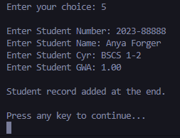

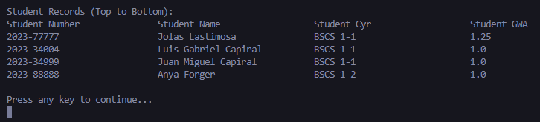

**Add a new record before a specific student number**

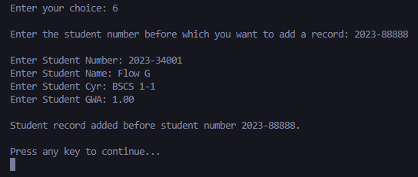

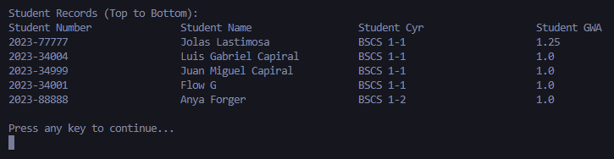

*(if not found)*

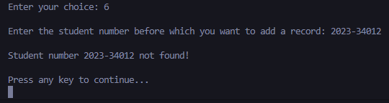

**Insert a new record after a specific student number**

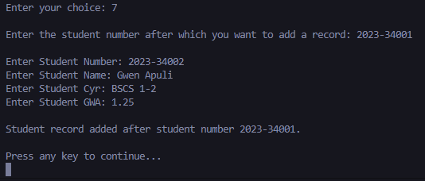

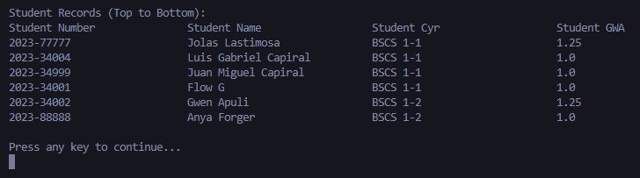

*(if not found)*

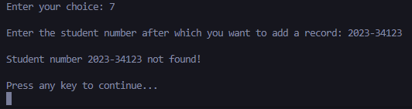

**Delete a record at the Head**

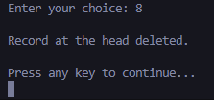

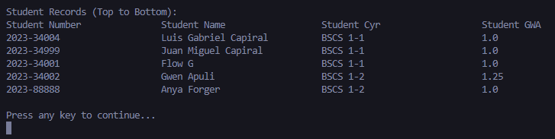

*(if empty list)*

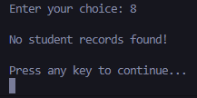

**Delete a record at the Tail**

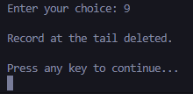

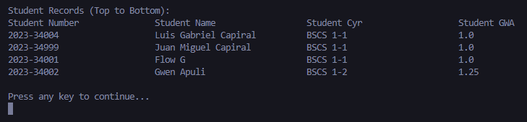

*(if empty list)*

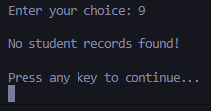

**Delete a record by student number**

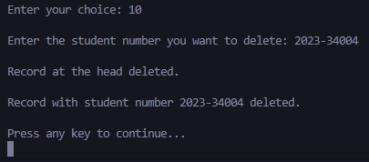

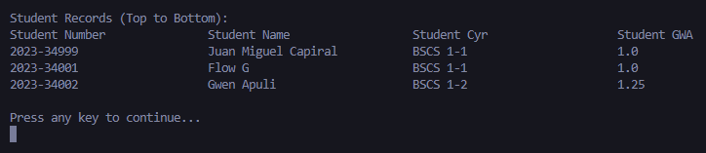

*(If not found)*

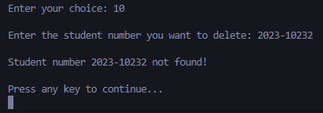

**Delete a record before a specific student number**

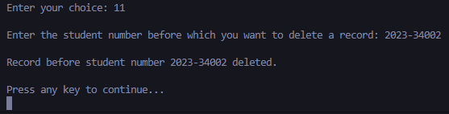

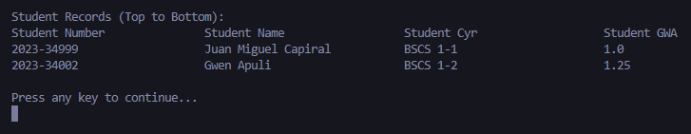

**Delete a record after a specific student number**

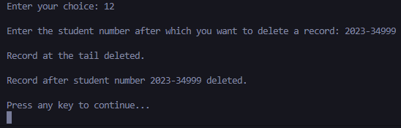

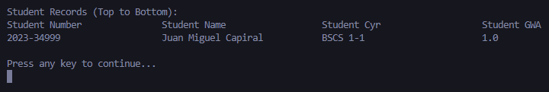

**Exit**

